Software Architecture Document

Online Streaming Platform 1.0

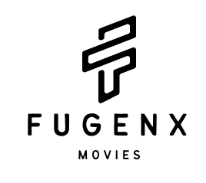

20Z316-DIYAA SANTHOSH
20Z325-R KAVIN ARAVINDHAN
20Z327-LAKSHMI PRIYADARSHINI M
20Z355-YADAV RANGANATHAN
20Z367-HARDIK P

PSG COLLEGE OF TECHNOLOGY
(Autonomous Institution)
COIMBATORE – 641 004

SAD Revision History

Date | Version | Description | Author
2022-09-27 | 0.1 | Architecture of FugenX | FuGenX

Table of Contents
1. INTRODUCTION 4
1.1 PURPOSE 4
1.2 SCOPE 4
1.3 DEFINITIONS,ABBREVIATIONS,ACRONYMS 5
2. ARCHITECTURAL REPRESENTATION 5
2.1 LOGIC VIEW 6
2.2 PROCESS VIEW 6
2.3 IMPLEMENTATION VIEW 6
2.4 USE CASE VIEW 6
2.5 DATA VIEW 7
3. ARCHITECTURAL GOALS AND CONSTRAINTS 7
3.1 TECHNICAL PLATFORM 7
3.2 TRANSACTION 7
3.3 SECURITY 7
3.4 PERSISTENCE 8
3.5 RELIABILITY/AVAILABILITY 8
3.6 PERFORMANCE 8
4. USE-CASE VIEW 9
5. LOGICAL VIEW 10
5.1 OVERVIEW 10
5.2 ARCHITECTURALLY SIGNIFICANT DEFINED PACKAGES 11
6. PROCESS VIEW 14
6.1 LOGIN 14
6.2 RECOMMENDATION SYSTEM 14
6.3 DATABASE ENTRY 14
7. IMPLEMENTATION VIEW 15
7.1 OVERVIEW 15
7.2 COMPONENT 16
8. DATA VIEW 17
9. SIZE AND PERFORMANCE 19
10. QUALITY 19

1. Introduction

Purpose

The Software Architecture Document (SAD) provides a comprehensive architectural overview of the Online Streaming Platform 1.0 offered by FugenX. It presents a number of different architectural views to depict different aspects of the system. It is intended to capture and convey the significant architectural decisions which have been made on the system.It will explain the system's various functional requirements, system interfaces, what the system will do, and the constraints under which it will operate. It also gives us an idea of what the users expect.

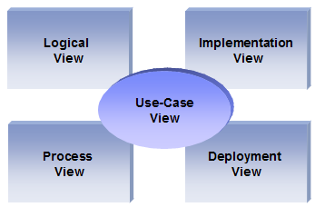

1.2 Scope

The scope of this SAD is to depict the architecture of the online Streaming application created by the company FugenX.

The scope of the product includes:

- The Online Streaming Platform is flexible and can quickly adapt to variable requirements.
- The recommendation system is based on content and popularity and partly includes collaborative filtering.
- Feature to allow users to create accounts.
- Allow users to customize their profiles.
- Allow users to handle multiple accounts.
- Allow users to watch videos.
- Let developers upload video from the backend and make it available on the platform.
- Allow content search for users to select different content genres.
- Multiple language support.
- Admin panel support to allow the main user to have access to all content to manage videos and users (block users if necessary).

1.3 Definitions, Acronyms and Abbreviations

RUP: Rational Unified Process
UML: Unified Modeling Language
SAD: Software Architecture Document

2. Architectural Representation

This document details the architecture using the views defined in the “4+1” model, but using the RUP naming convention. The views used to document the FuGenX application are:
2.1 Logical view

Audience: Designers.
Area: Functional Requirements: describes the design's object model. Also describes the most important use-case realizations.
Related Artifacts: Design model

2.2 Process view

Audience: Integrators.
Area: Non-functional requirements: describes the design's concurrency and synchronization aspects.
Related Artifacts:

2.3 Implementation view

Audience: Programmers.
Area: Software components: describes the layers and subsystems of the application.
Related Artifacts: Implementation model

2.4 Use Case view

Audience: all the stakeholders of the system, including the end-users.
Area: describes the set of scenarios and/or use cases that represent some significant, central functionality of the system.
Related Artifacts : Use-Case Model, Use-Case documents

2.5 Data view

Audience: Data specialists, Database administrators
Area: Persistence: describes the architecturally significant persistent elements in the data model
Related Artifacts: Data flow diagram.

3. Architectural Goals and Constraints

This section describes the software requirements and objectives that have some significant impact on the architecture

3.1 Technical Platform

The FuGenX will be deployed onto a web server.

3.2 Transaction

The FuGenX online application is transactional, leveraging the technical platform capabilities. Transaction management model will be reused intensively.

3.3 Security

The system must be secured, so that a customer can share account details.
The application must implement basic security behaviors:
- Authentication: Login using at least a user name and a password
- Authorization: according to their profile, users(admin, customers) must be granted or not to perform some specific actions
For internet access, the following requirements are mandatory
- Confidentiality: sensitive data must be encrypted (credit card payments)
- Data integrity : Data sent across the network cannot be modified by a tier
- Auditing: Every sensitive action can be logged
- Non-repudiation : gives evidence a specific action occurred

3.4 Persistence

Existence of data over time will be addressed using a relational database to store the details of the user,movie and watchlist of the user.

3.5 Reliability/Availability

The availability of the system is a key requirement by nature, as it is a selling system.Targeted availability is 24/7: 24 hours a day, 7 days a week

3.6 Performance

This application should be efficient and fast since it involves reputed companies' actions. The payment process (credit card authorization and confirmation) must be under 10 seconds.

4. Use-Case View

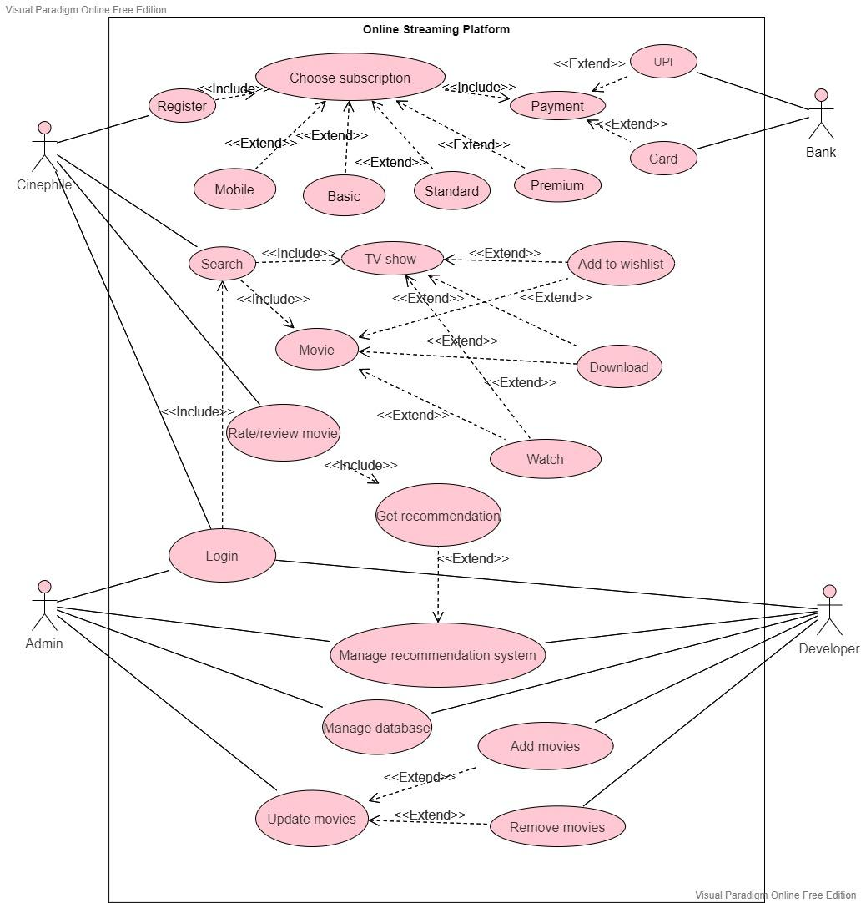

This section lists use cases or scenarios from the use-case model if they represent some significant, central functionality of the final system. The use-case with a significant impact on the FugenX is the one related to search movies,get recommendations, manage movie databases and pay subscription.

5. Logical View

5.1 Overview

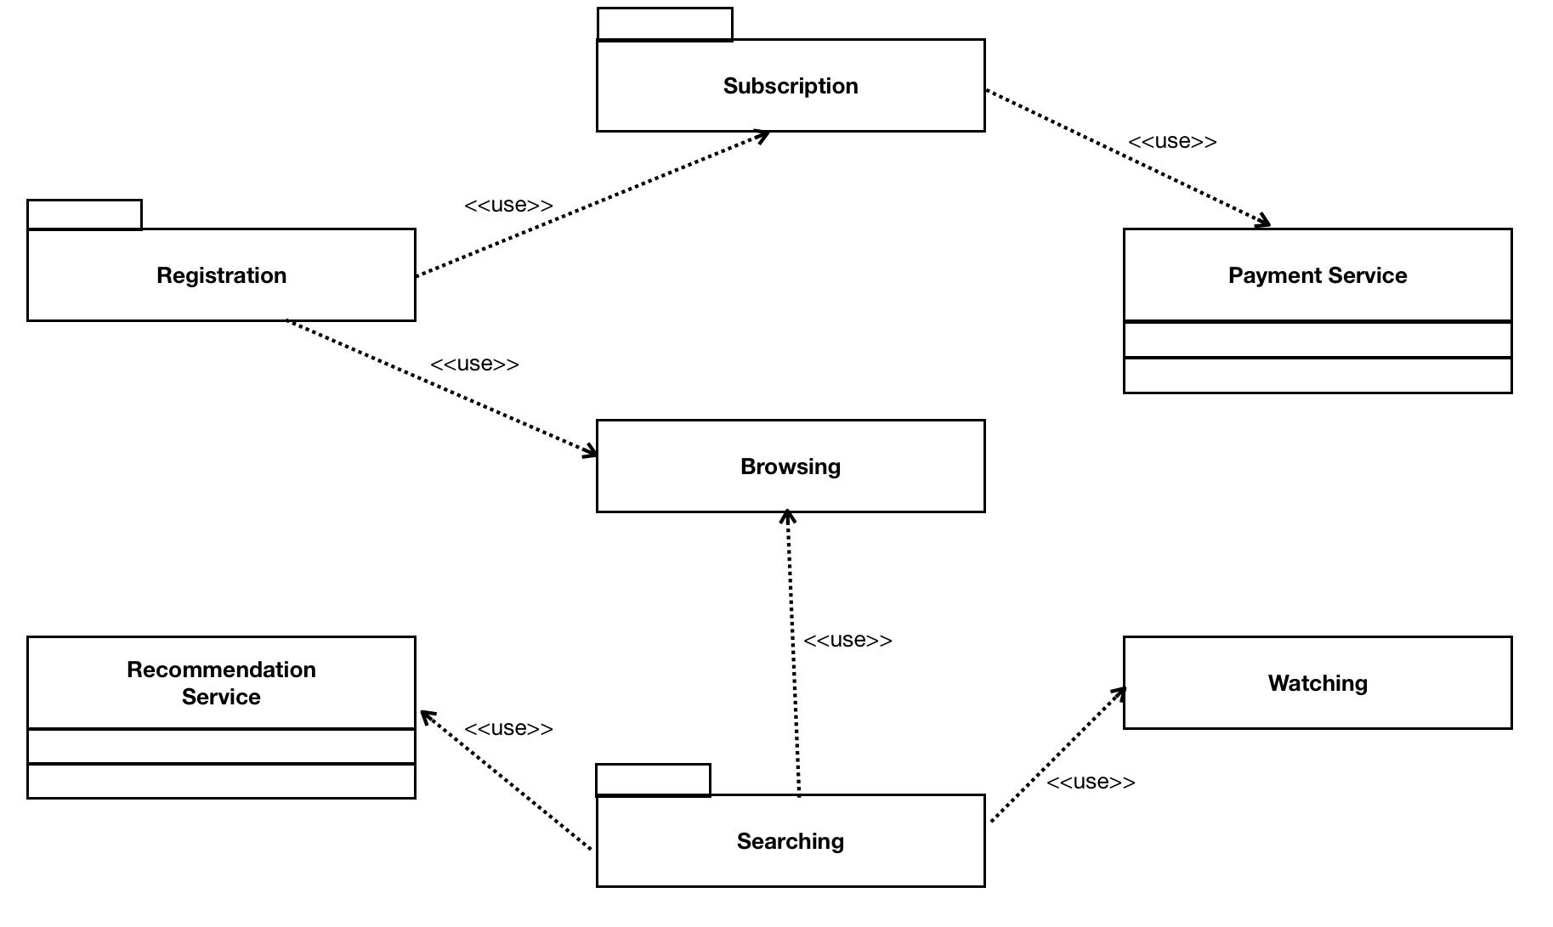

The online Streaming application version 1.0, The ability to search for movies is the platform's main feature. Allows users to stream privately and chat with other users through the platform. It also allows users to search for content and choose from a variety of content genres. Users can use the platform in a variety of languages. The user can manage multiple accounts as well as personalize their profiles. They will allow users to save their favorite videos so that they can return to them at a later time, as many sites now allow users to do.

5.2 Architecturally Significant Design Packages

5.2.1. Login

Registered users login to the system with their credentials. New user can create an account and select a subscription to proceed with searching and watching functionalities.

5.2.2 Searching movies

FugenX allows its user to search the film on the basis of film name, genre and actor. Content based recommendation using cosine similarity is used to list the films similar to the one searched by the user.

5.2.3 Subscription
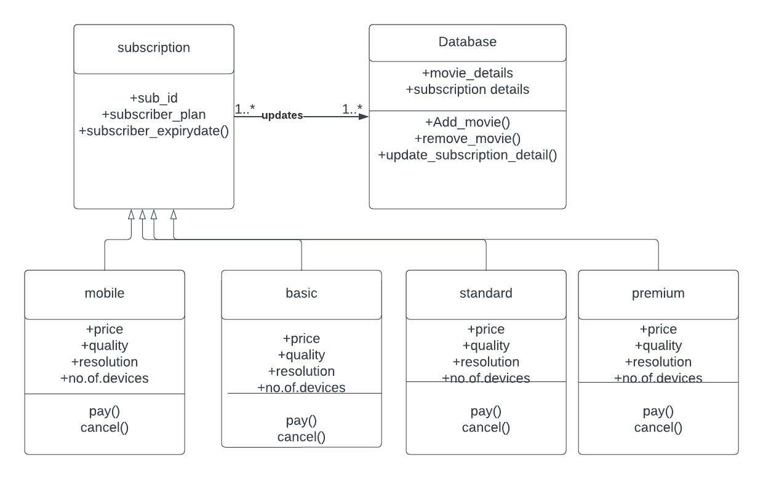

5.2.4 Payment service
Contains all the logic related to the online payment and credit card validation.The Payment Service is an external subsystem documented in its own Software Architecture Document.

5.2.5 Flow of FugenX:
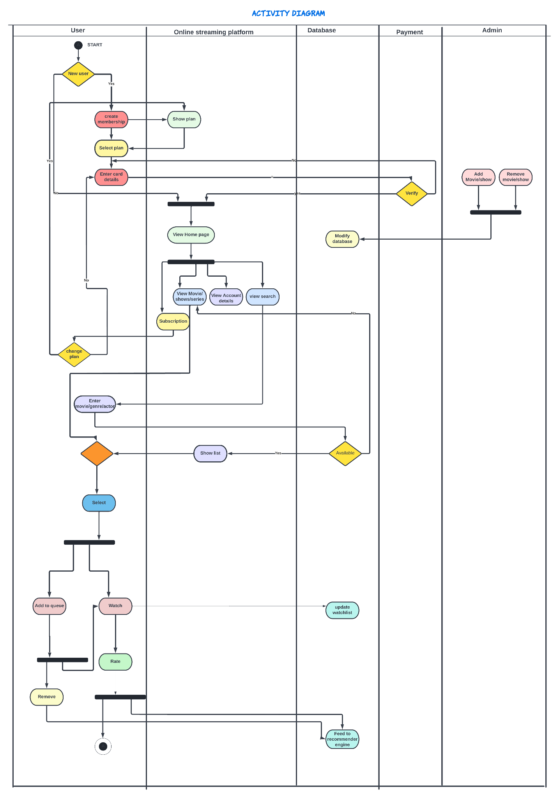

6. Process View

6.1 Login:

Login enables a user to sign in or create an account on a fuGenX using existing user credentials from a social networking service. Firebase is a backend platform used for developing Web, Android, and iOS applications. Firebase stores the usernames and passwords of the users and compares them for verification; if OK, the user is permitted to login; otherwise, the login fails.

6.2 Recommendation System:

The recommendation system is where we search for movies that will play as input role and users can search for movies with different joners, and the recommendation system will respond with movie offers from the database that are relevant to their search. It also selects the image of the movie that the user searched for or movies that are related to the search and displays it to the users.

6.3 Database Entry:

FugenX makes use of the Firebase database system. Data is stored in databases by FugenX. The database contains movie information and is used to remove any outdated films.

7. Implementation View

7.1 Overview

The Implementation view depicts the physical composition of the implementation in terms of Implementation Subsystems, and Implementation Elements (directories and files, including source code, data, and executable files).
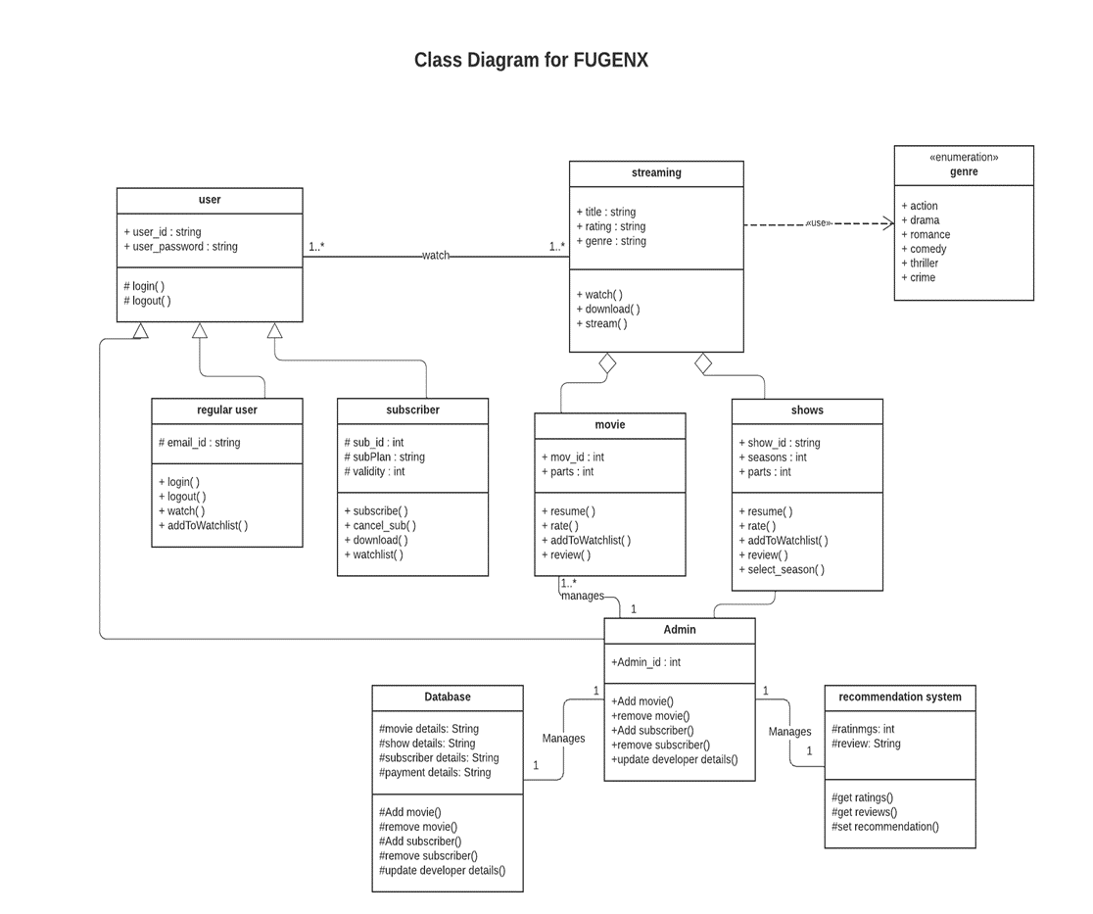

7.2 Component

There are four main components in the application, Recommendation module, Search module, payment/subscription module and Account module.

Recommendation module

- Recommendation module is responsible for recommending films based on the content.
- Users can enter a movie name, a set of five to ten films based on the cosine similarity metric.

Search module

Search module is responsible to get user input and make a search on the categories of genre, actor and film.

Payment Module

- Users can make payment/ subscribe to different services which in turn are updated to the database.
- Users can cancel or renew subscriptions any time.

Account Module

- The Account module is responsible to hold the details of registered users. This module is associated with the payment module to hold the details of the subscription opted by the user.
8. Data View

The key data elements related to the FugenX are:
- Login credentials of the user.
- New Movie updates by the admin.
- Subscription details of the user.
- Watch list of each user.
- movie list with and without recommendation.
All are maintained in the database.

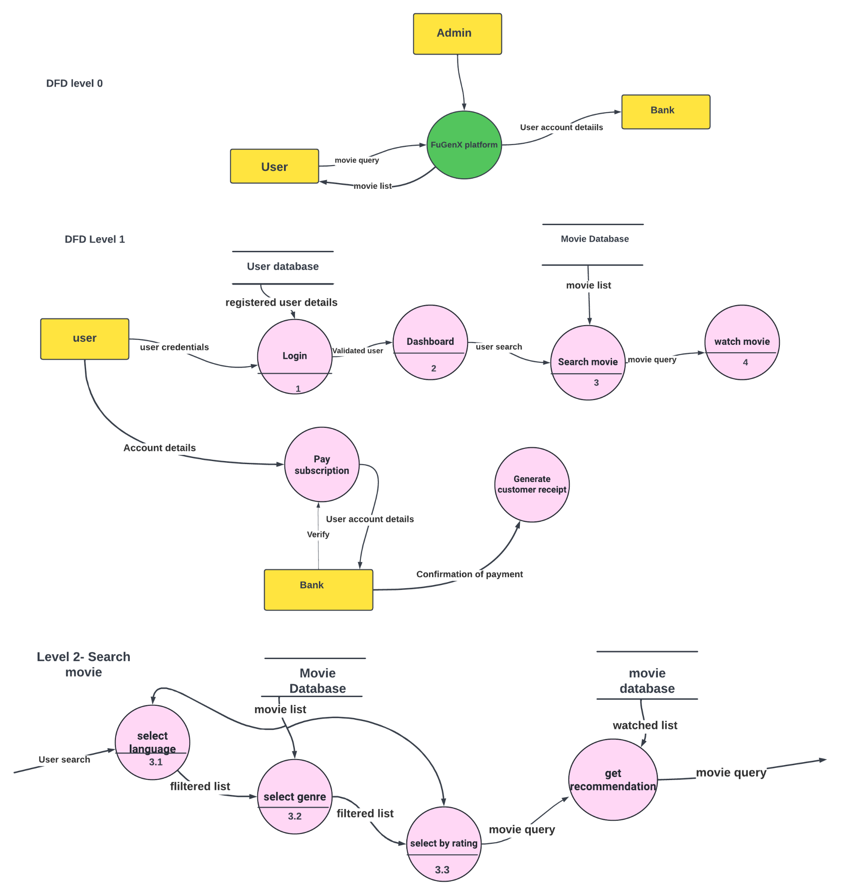

9. Size and Performance

Volumes:
- Estimated online accesses : Since it is a online server, it can have adequate
number of users
Performance:
- Time to process and online payment (credit card validation + confirmation) : less than 10 seconds required
- Time to provide search results : less than 5 seconds required
- Time to start playing the video : less than 5 seconds required
- Time to provide recommendations based on previously watched movies/shows : less than 10 seconds required

10. Quality

As far as the Online Streaming Platform is concerned, the following quality goals have been identified:

Scalability:
- Description : System’s reaction when user demands increase.
- Solution : Firebase server supports several workload management techniques. Since this is a web server based package, scalability is ensured.
Reliability, Availability:
- Description : Transparent failover mechanism, mean-time-between-failure.
- Solution : : This platform ensures reliable video playback. Firebase server supports load balancing through clusters.
Portability:
- Description : Ability to be reused in another environment.
- Solution : Since it is a web server, it can be accessed anywhere online.
Security:
- Description : Authentication and authorization mechanisms.
- Solution : Google authentication using Firebase is used to ensure security.

